Types of HDLC Frames
# Source: AI Source: Provided by: [Data Path: Persons Table -> ID Column: 1, Name_En Column: Motasem Essam] -> From: [ChatGPT] on [1/16/2026]
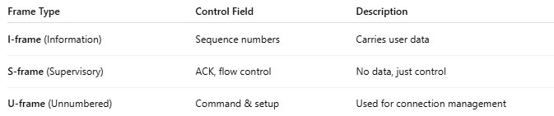
Frame Type | Control Field | Description
I-frame (Information) | Sequence numbers | Carries user data
S-frame (Supervisory) | ACK, flow control | No data, just control
U-frame (Unnumbered) | Command & setup | Used for connection management

